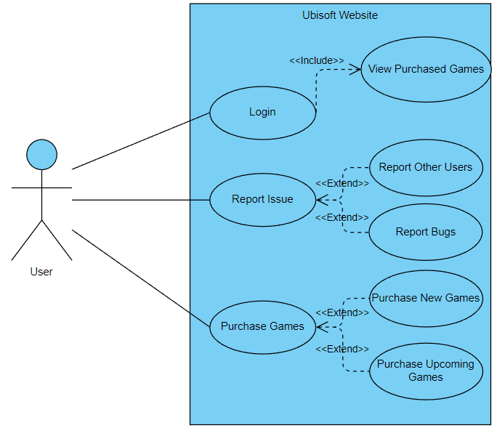Use Case Diagram

Components

Actor / User (Stick Person):

The actor in our diagram is a gamer. They are the focal point of our website. The main purpose of the website is to attract gamers to use and buy Ubisoft games / products.

System / Subject (The Blue Rectangle):

The system in our diagram in the Ubisoft website. The website is a platform that anyone can visit. It allows it users to browse games, purchase games, and contact Ubisoft.

Use Cases (The Blue Ovals):

The system has 8 use cases, 3 of which are the main focus of our system

1. Account Management / Login
   1. One of the main use cases is ability to login to Ubisoft and manage your games.
   2. This allows users to view and download their purchased games.
2. Contract Us / Report
   1. Another main use case gives the users the ability to contact support or report any issues they face to Ubisoft.
   2. This allows users to submit reports on bugs that they encounter during their playtime.
   3. This allows users to submit reports on other players that are not following Ubisoft’s rules.
3. Game Store
   1. The final main use case is the ability to visit the store page and view games.
   2. This allows users to purchase released games.
   3. This allows users to pre-order games.